MiSACWIS Project

PM01h – Maintain Person Characteristics Screen Specification
Version 2.4

August 18, 2011
Prepared for:


120 N. Washington Square
SACWIS Project, 3rd Floor
Lansing, MI 48933

Prepared by:

Revision Log
Version | Date | A/D/C (Add, Delete, Change) | Author | Document Section # | Description
0.1 | 08/09/2011 |  | Srikanth Vietla |  | Initial version
1.0 | 08/16/2011 | A,C | Samaad Seales | All | Approved
1.1 | 09/21/2011 | C | Venkat Gadwal | 3.1.3, 3.2.3 | Quality Assurance Review:  Updated To Be Type, To Be Calculations and UI Validations in Section 3.1.3, 3.2.3.  No functionality impact. Updated information highlighted in yellow.
2.0 | 09/07/2011 | C | Samaad Seales | All | Approved
2.1 | 11/17/2011 | C | Samaad Seales | All | CC# 1518
2.2 | 02/03/2012 | C | Samaad Seales | 2.1.3 | CC# 3291
2.3 | 08/07/2012 | C | Mike Stubbs | 3.1.5.4 | Updated status of this BR to ‘Delete’ per CC#15468
2.4 | 08/18/2012 | C | Samaad Seales | 3.1.5 | CC#15402
Table of Contents
1 Introduction 5
1.1 Purpose 5
1.2 Scope 5
2 Use Case Details 6
2.1.1 Action Buttons/Hyperlinks 6
2.1.2 Business Rules 7
2.1.3 Security Requirements 7
2.1.4 Screen Navigation 7
2.1.5 Tab Order 7
2.1.6 Pre-Conditions 7
2.1.7 Ticklers 8
2.1.8 Notifications 8
2.1.9 Calendar 8
2.1.10 Reports 8
2.1.11 Notes and Assumptions 9
3 Screen Details 10
3.1 S01 –View Person Characteristics List Screen 10
3.1.1 As Is - Screen Mock Up 10
3.1.2 To Be – Screen Mock Up 11
3.1.3 Screen Fields 12
3.1.4 Action Buttons/Hyperlinks 15
3.1.5 Business Rules 15
3.1.6 Screen Navigation 16
3.1.7 Pre-Conditions 17
3.1.8 Reference Values 17
3.2 S02 - Person Characteristics Details Page 18
3.2.1 As Is - Screen Mock Up 18
3.2.2 To Be - Screen Mock Up 19
3.2.3 Screen Fields 20
3.2.4 Action Buttons/Hyperlinks 23
3.2.5 Business Rules 23
3.2.6 Screen Navigation 25
3.2.7 Preconditions 25
3.2.8 Reference Values 25

List of Figures
Figure 1 – View Person Characteristics List 9
Figure 2 – View Person Characteristics List 10
Figure 3 –Person Characteristics Details 16
Figure 4 –Person Characteristics Details 16

- Introduction

Purpose
Placement process in the State of Michigan involves finding a suitable provider with whom the child(ren) will be potentially placed. As per the current Michigan’s DHS policy, a child(ren) temperament and personality characteristics must be taken into consideration before placing the child(ren) with the placement provider. For example the child may be shy, timid, boisterous, bossy, attention seeking, anxious, honest, outgoing and social, bold, calm/laid back etc. These characteristics are either observed or reported characteristics of the child(ren) demeanor.
The Person Characteristics use case in MISACWIS will be used to record and maintain these characteristics of a person that will be used to assist caseworkers in finding a suitable placement for a person.

Scope

This document describes the Services Specialist, Worker and Supervision’s ability to access, record and maintain a child (ren) characteristics in the MISACWIS system.
- Use Case Details
    - Action Buttons/Hyperlinks
Status (Keep/Add/Modify/Delete) | Label | Type | On Click Action/Navigation
Keep | Apply | Button | System saves the selected drop down values and enterable field values. Characteristic Group, Characteristic, Sub Category, Verification, Reported Date, Inactive Date and the Comments text box. User is kept on the same page.
Keep | Save | Button | System saves the selected drop down values and enterable field values. Characteristic Group, Characteristic, Sub Category, Verification, Reported Date, Inactive Date and the Comments text box. User is returned to the calling page.
Keep | Cancel | Button | All changes are ignored and the record is closed. User is taken to the Person Characteristics page. Presented only when the record is in editable mode.
Keep | Close | Button | Returns worker to the Person Overview page. Presented only when the record is in read only mode.
Keep | Spell Check | Button | Performs spell check on the associated text field.
Keep | Clear | Button | Clears all text from associated text field.
Keep | Help | Hyperlink | Screen-level help will appear in a separate browser window.

    - Business Rules
No. | Status (Keep/Add/Modify/Delete) | Business Rule Description | Modified Business Rule Description | Execution Event (field tab out/save etc) | Error Msg Code  To be completed by Development Team
1
2
    - Security Requirements
No. | Status (Keep/Add/Modify/Delete) | Security Requirement
1 | Keep | All security for PM01h is derived from the security for PM01.
    - Screen Navigation
No. | Status (Keep/Add/Modify/Delete) | To Screen Navigation Path
1 | Keep | List page is accessed from Person Overview (PM01i); detail page is accessed from List page.
    - Tab Order
No. | Status (Keep/Add/Modify/Delete) | Screen name
N/A
    - Pre-Conditions
No. | Status (Keep/Add/Modify/Delete) | Pre-Condition
1 | Keep | A Person record exists in MiSACWIS
    - Ticklers
Status (Keep/Add/Modify/Delete) | Tickler Name | Trigger Action | Tickler Generation Business Rule & Description | Tickler Removal Business Rule | Tickler Text
Status (Keep/Add/Modify/Delete) | Tickler Role
 | N/A
    - Notifications
Status (Keep/Add/Modify/Delete) | Notification Name | Trigger Action | Message Business Rule & Description | Message Text
Status (Keep/Add/Modify/Delete) | Notification Role | Trigger Action | Message Business Rule & Description | Message Text
Add | SSI Eligibility Screening | When a child characteristics record is saved/applied with the characteristic group type = 'Disability' and the Inactive Date is null. | <Only one of these notifications will be sent per day, per child> | <"'CHILD_NAME','CHILD_ID may be eligible for SSI Benefits ">
Add | Reconciliation and Recoupment  Foster Care Specialist |  |  | <"'CHILD_NAME','CHILD_ID may be eligible for SSI Benefits ">

    - Calendar
Status (Keep/Add/Modify/Delete) | Calendar Name | Trigger Action | Calendar Event Generation Business Rule & Description | Calendar Event Date and Time Business Rule | Calendar Event Text
Status (Keep/Add/Modify/Delete) | Calendar Role
 | N/A
    - Reports
None
    - Notes and Assumptions
- Screen Details
  - S01 –View Person Characteristics List Screen
    - As Is - Screen Mock Up
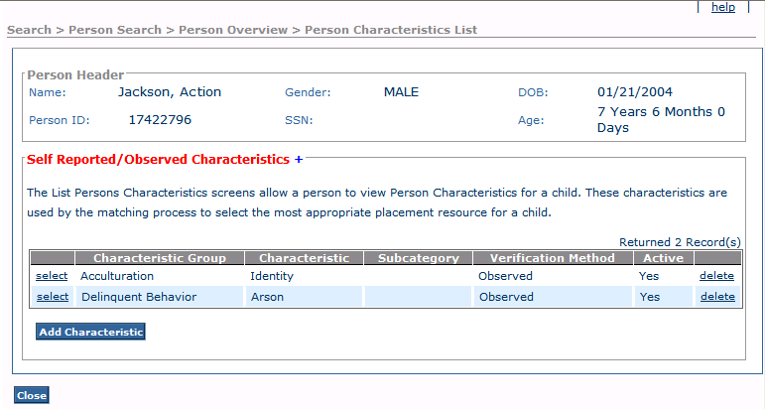
Figure 1 – View Person Characteristics List
    - To Be – Screen Mock Up
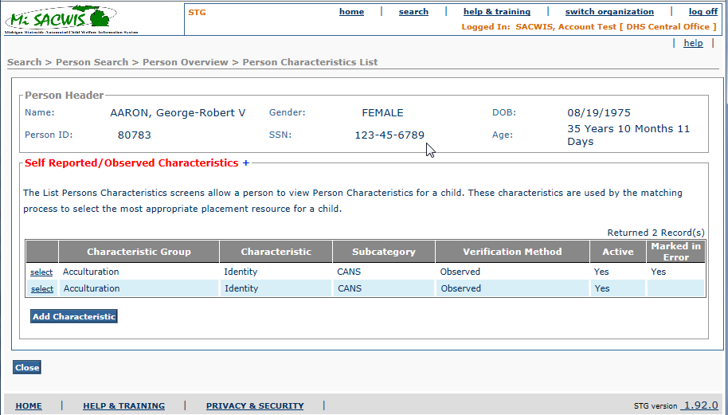

Figure 2 – View Person Characteristics List

    - Screen Fields
.
Status (Unchanged/Add/Modify/Delete) | As Is  Class.Attribute Name | To Be  Class.Attribute Name | As Is Display Name | To Be Display Name | To Be Type | To Be Align | To Be Size | To Be Read Only | To Be Calculation | To Be Edit Mask | To Be  UI Validation
Keep | N/A | N/A | Person Header | Person Header | Section Header
Keep | Person.lastName + Person.firstName + Person.middleName | Person.lastName + + Person.suffixCode + Person.firstName + Person.middleName | Name | Name | Display Text | L | 100 | T |  | Last Name, Suffix Code, First Name  Middle Name
Keep | Person.personID | Person.personID | Person ID | Person ID | Display Text | L | 30 | T
Keep | Person.SSN | Person.SSN | SSN | SSN | Display Text | C | 11 | T |  | ###-##-####
Keep | Person.birthDate | Person.birthDate | DOB | DOB | Display Text | C | 7 | T |  | MM/DD/YYYY
Keep | Person.genderCode | Person.genderCode | Gender | Gender | Display Text | R | 30 | T | Use Short Desc from Ref Data where Domain Category = ‘Gender'
Keep |  |  | Age | Age | Display Text | R | 30 | T | Subtract Person.birthDate from System Date | ### Years  ## Months  ### Days | .
Keep | N/A | N/A | Self Reported / Observed Characteristics | Self Reported / Observed Characteristics | SectionHeader | L | N/A | T
Keep | Characteristic.characteristicGroupCode | Characteristic.characteristicGroupCode | Characteristic Group | Characteristic Group | Display Text | L | 30 | T
Keep | Characteristic.characteristicCode | Characteristic.characteristicCode | Characteristic | Characteristic | Display Text | L | 30 | T
Keep | Characteristic.subCategoryCode | Characteristic.subCategoryCode | Subcategory | Subcategory | Display Text | L | 30 | T
Keep | Characteristic.observed_code | Characteristic.selfReportedCode  Or  Characteristic.observedCode | Verification Method | Verification Method | Display Text | L | 30 | T
Keep | N/A | N/A | Active | Active | DisplayText | L | 3 | T | Refer to Business Rules (section 3.1.5)
Add | N/A | Characteristic.markedInErrorFlag | N/A | Created in Error | Display Text | L | 3 | T | Refer to Business Rules (section 3.1.5)

    - Action Buttons/Hyperlinks
Status (Keep/Add/Modify/Delete) | Label | Type | On Click Action/Navigation
Keep | Add Characteristic | Button | Launches the Person Characteristic Details page
Keep | Select | Hyperlink | Access point for Person Characteristics Details page. Upon selection displays the selected person characteristic information in edit mode.
Delete | Delete | Hyperlink | Deletes the selected person Characteristic record.
Keep | Help | Hyperlink | Screen-level help will appear in a separate browser window.
Keep | Close | Button | Closes page, and returns to the Person Overview page.
    - Business Rules
No | Status (Keep/Add/Modify/Delete) | Business Rule Description | Modified Business Rule Description | Execution Event (field tab out/save etc) | Error Msg Code  To be completed by Development Team
1 | Keep | On the list page, a column will use an indicator to identify whether a Person Characteristic is Active.  Calculated based on the Inactive Date of the person. If NULL = ‘Yes’ ELSE = ‘No’
3 | Modify | The sort order is alphabetic within Active Characteristics, followed by alphabetic within Inactive Characteristics. | The sort order is by date followed by:  1. alphabetic within Active Characteristics, followed by  2. alphabetic within Inactive Characteristics,  3. alphabetic Inactive "Marked in Error" Characteristics.
4 | Delete | The Clinically Diagnosed fields will be read only from the Characteristics page. The system will pre-fill this information as documented in the Medical History pages associated to the child. This will occur either from generation of a new characteristic record or update of an existing characteristic record.
5 | Keep | Selecting the Select hyperlink navigates to the associated Person Characteristic record. Closing that record returns the user to the Person Characteristics list page.
6 | Delete | If the user has only View rights to the Characteristics, the Delete hyperlink will not be visible on any of the rows.
    - Screen Navigation
No. | Status (Keep/Add/Modify/Delete) | To Screen Navigation Path
1 | Keep | List page is accessed from Person Overview (PM01i); detail page is accessed from List page.
    - Pre-Conditions
No. | Status (Keep/Add/Modify/Delete) | Pre-Condition
1 | Keep | A Person record exists in MiSACWIS
2 | Keep | Must have Person Characteristics hyperlinked from the Person Overview page.
3 | Keep | Person ID must be in focus
    - Reference Values
No. | Status (Keep/Add/Modify/Delete) | To Be Class Attribute | Domain Code | Short Desc | Ref Data Code
 | N/A

  - S02 - Person Characteristics Details Page
    - As Is - Screen Mock Up
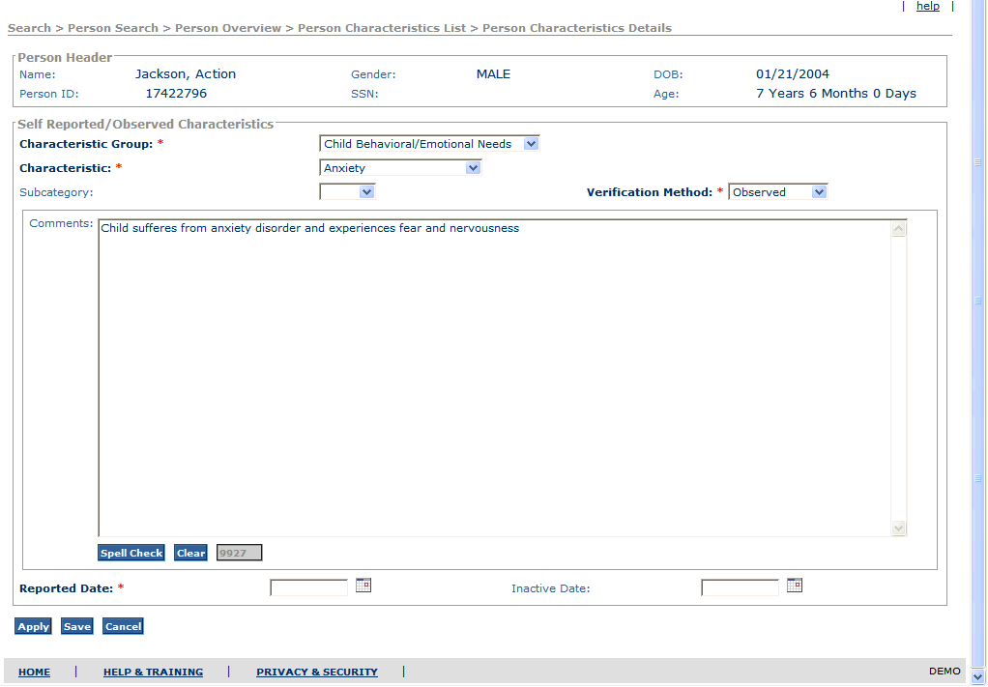
Figure 3 –Person Characteristics Details

    - To Be - Screen Mock Up
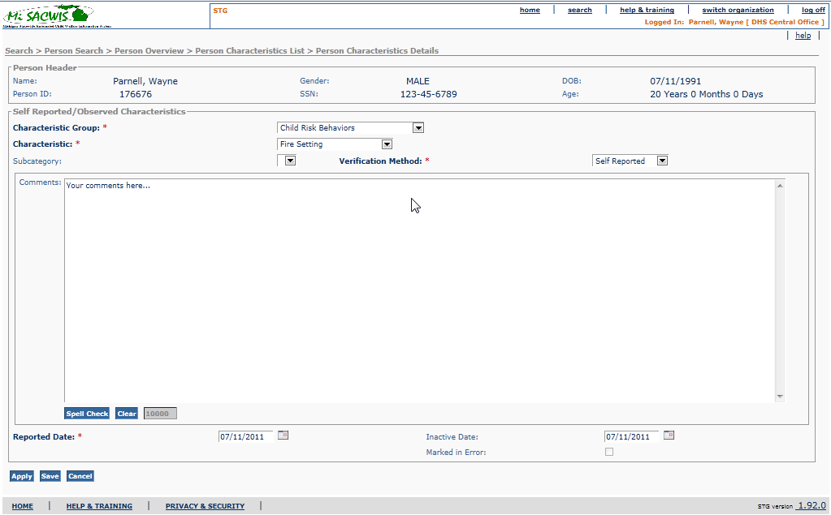

    - Screen Fields
Status (Unchanged/Add/Modify/Delete) | As Is  Class.Attribute Name | To Be  Class.Attribute Name | As Is Display Name | To Be Display Name | To Be Type | To Be Align | To Be Size | To Be Read Only | To Be Calculation | To Be Edit Mask | To Be  UI Validation
Keep | N/A | N/A | Person Header | Person Header | Section Header
Keep | Person.lastName + Person.firstName + Person.middleName | Person.lastName + + Person.suffixCode + Person.firstName + Person.middleName | Name | Name | Display Text | L | 100 | T |  | Last Name, Suffix Code, First Name  Middle Name
Keep | Person.personID | Person.personID | Person ID | Person ID | Display Text | L | 30 | T
Keep | Person.SSN | Person.SSN | SSN | SSN | Display Text | C | 11 | T |  | ###-##-####
Keep | Person.birthDate | Person.birthDate | DOB | DOB | Display Text | C | 7 | T |  | MM/DD/YYYY
Keep | Person.genderCode | Person.genderCode | Gender | Gender | Display Text | R | 30 | T | Use Short Desc from Ref Data where Domain Category = ‘Gender'
Keep |  |  | Age | Age | Display Text | R | 30 | T | Subtract Person.birthDate from System Date | ### Years  ## Months  ### Days | .
keep | Characteristic.characteristicGroupCode | Characteristic.characteristicGroupCode | Characteristic Group | Characteristic Group | Drop DownList | L | 100 | F | Domain Code: ChildCharacteristicGroup |  | User selected  Required
keep | Characteristic.characteristicCode | Characteristic.characteristicCode | Characteristic | Characteristic | Drop DownList | L | 100 | F | Domain Code: ChildCharacteristicType |  | User selected  Required
keep | Characteristic.subCategoryCode | Characteristic.subCategoryCode | Subcategory | Subcategory | Drop DownList | L | 100 | F | Domain Code: ChildCharacteristicSubType |  | User selected  Not Required
keep | Characteristic.observedCode | Characteristic.selfReportedCode  Or  Characteristic.observedCode | Verification Method | Verification Method | Drop DownList | L | 100 | F | Domain Code: VerificationMethod |  | User selected  Required
keep | Characteristic.additionalInformation | Characteristic.additionalInformation | Comments | Comments | Text Field | L | 4000 | F |  |  | User Entered  Not Required
keep | Characteristic.observationDate | Characteristic.observationDate | Reported Date | Reported Date | DateField | L | 10 | F |  | MM/DD/YYYY | User Entered  Required
keep | Calculate based on - Characteristic.inactiveDate | Calculate based on - Characteristic.inactiveDate | Inactive Date | Inactive Date | DateField | L | 10 | F | Refer to Business Rules section 3.2.5 | MM/DD/YYYY | User Entered  Not Required
Add |  | Characteristic.markedInErrorFlag |  | Marked in Error | Checkbox | L | N/A | T |  |  | User Selected  Not Required

    - Action Buttons/Hyperlinks
Status (Keep/Add/Modify/Delete) | Label | Type | On Click Action/Navigation
Keep | Apply | Button | System saves the selected drop down values and enterable field values. Characteristic Group, Characteristic, Sub Category, Verification, Reported Date, Inactive Date and the Comments text box. User is kept on the same page.
Keep | Save | Button | System saves the selected drop down values and enterable field values. Characteristic Group, Characteristic, Sub Category, Verification, Reported Date, Inactive Date and the Comments text box. User is returned to the Person Characteristics List page.
Keep | Cancel | Button | All changes are ignored and the record is closed. User is returned to the Person Characteristics List page.
Keep | Spell Check | Button | Performs spell check on the associated text field.
Keep | Clear | Button | Clears all text from associated text field.
Add | Marked in Error | Checkbox | When the user enters a check in this box, the inactive date field will be populated with the system date.
    - Business Rules
No. | Status (Keep/Add/Modify/Delete) | Business Rule Description | Modified Business Rule Description | Execution Event (field tab out/save etc) | Error Msg Code  To be completed by Development Team
1 | Keep | - Required fields are Characteristic Group, Characteristic, Verification Method, Reported Date.  - Subcategory is a conditional field  - All Characteristics must be a part of a Characteristic Group and must be presented as a dropdown for the selected Category Group.  - If a Characteristic has one or more Subcategories, the system must present a dropdown with all of the Subcategories for that Characteristic.
2 | Modify | The Reported Date cannot exceed the system date. | Reported Date cannot be a future date, and cannot be prior to the child's DOB | Apply/Save
3 | Keep | Inactive Date validation: Reported Date <= Inactive Date <= System Date.
4 | Keep | System must display the Person Characteristics Details for the Characteristic record selected on the Person Characteristics List page
5 | Add | Once a characteristic record is "Marked in Error" the record is frozen and cannot be edited. |  | Upon Apply/Save
6 | Add | Once an Inactive Date is populated within a person characteristic record, the record is frozen and is no longer editable. |  | Upon Apply/Save

    - Screen Navigation
No. | Status (Keep/Add/Modify/Delete) | To Screen Navigation Path
1 | Keep | Accessed from Person Maintain Characteristics (S01)

    - Preconditions
No. | Status (Keep/Add/Modify/Delete) | Pre-Condition
1 | Keep | The Person record exists in MiSACWIS
2 | Keep | Must have Person Characteristics hyperlinked from the Person Overview page.
3 | Keep | Person ID must be in focus

    - Reference Values
No. | Status (Keep/Add/Modify/Delete) | To Be Class Attribute | Domain Code | Short Desc | Ref Data Code
1 | Keep | Characteristic.characteristicGroupCode | ChildCharacteristicGroup
2 | Keep | Characteristic.characteristicCode | ChildCharacteristicType
3 | Keep | Characteristic.subCategoryCode | ChildCharacteristicSubType
4 | Modify | Characteristic.observedCode | VerificationMethod | Observed
 |  | Characteristic.observedCode | VerificationMethod | Reported
 |  |  |  | Diagnosed

